Learning Continuity and Attendance Plan Template (2020–21)
Local Educational Agency (LEA) Name | Contact Name and Title | Email and Phone
Hawking STEAM Charter School | Lorena Chavez, Executive Director | lchavez@hawkingcharter.org  (619) 483-3008

General Information
[A description of the impact the COVID-19 pandemic has had on the LEA and its community.]
Hawking STEAM Charter School (TK-8) educational platform integrates STEAM-focused Project-based learning experiences to prepare its students for success in college and career. Our school is located in 2 sites: Chula Vista and South San Diego.
On March 4, 2020, CA Governor Gavin Newsom declared a State of Emergency to help the state prepare for broader spread of COVID-19. This immediately triggered the Hawking Leadership Team comprised of the Executive Director, Principals and Instructional Coaches for each school, to meet and develop a Distance Learning Plan, a Technology Needs Assessment, Professional Development Plan, and identify resources for families during school closure.
With the transition to Distance Learning, we focused on the delivery and quality of instruction in addition to the shift of our current curriculum to web-based/online format. Our plan outlined the shift in roles and responsibilities of school staff to ensure an expeditious transition to Distance Learning, while ensuring that the needs of all students and families were being met. This included schoolwide expectations for staff, parents and students and measuring the impact of our program through surveys and feedback.
Technology Needs assessment took place the week of March 9th – families were surveyed to identify technology and internet needs. The initial distribution of devices took place on March 13th and then again, the weeks of March 16; and April 6th. Approximately 600 devices were distributed. Later, wi-fi hotspots were also distributed to families in need. Families were provided with resources to acquire free/reduced cost internet services from local Internet Service Providers. Our offices remained open to provide tech support, replacement of devices; and access to hard copies of instructional materials, as needed or requested by parents.
A few days before our school’s closure of March 13th, the instructional coaches met with teachers to discuss the Distance Learning Plan. Teachers participated in professional development on implementing effective Google Classrooms (Beginner/Advanced). In the following weeks and throughout Distance Learning, all teachers continued to participate in professional development on the following web-based tools: Screencast-o-matic, SMART casting, Edulastic (Basic/Adv), SeeSaw. All trainings were recorded so that teachers could access them as a refresher; and to build a PD library for our staff.
March 13th was the last day of site-based instruction. The majority of our students were sent home with 1 week of coursework (packets) and workbook for the lower grades and laptops for upper grades.
Distance Learning expectations were developed and shared with students and families. The team developed a website specifically for student resources and a separate one for parent resources that includes a list of responsibilities during Distance Learning and video tutorials on accessing Google Classroom and Hangouts. A website listing all Distance Learning resources was also developed that housed all instructional materials.
Distance Learning started on Monday March 16th. Teachers set up their Google classrooms and/or weebly websites that served as the primary learning platform for students. All pre-recorded lessons (asynchronous) instruction were uploaded to this site, that was shared with their students and parents. Our school established a Distance Learning website for each school site.
Within a few weeks of distance learning, our students, and parents were surveyed to identify strengths and areas for growth with our Distance Learning. Students reported that the major impact of school closure was a combination of struggling with time management, lack of social interaction with peers, isolation, lack of motivation, and for students who lack structure at home, focusing on schoolwork was challenging. For parents, distance learning was challenging and stressful, especially for those who were unable to assist their child with assignments, dealing job and food insecurity, in addition to the escalating COVID-19 cases in the community. In response to surveys and feedback from students and parents, our teachers shifted to more synchronous instruction, and built-in breaks in between sessions, added online games allowing students to socially interact in a virtual setting, and increased group work time, social time and increased morning meeting activities for students. Additionally, specific grade levels conducted lessons on time management. School support staff communicated with parents/families on a regular basis to identify school and community resources to support them. Many parents expressed satisfaction with the school’s transition to Distance Learning, level of organization among staff, resources provided for parents/students, and ongoing communication between school and home.

Despite all of these challenges, for the period of time our school transitioned to distance learning (March – June), student attendance remained at 96% as documented daily by our teachers during synchronous instruction. This plan includes what we’ve learned from last Spring, and how the delivery of instruction and our educational program will be delivered for the 2020-21 school year based on extensive research, best practices, and feedback from our stakeholders.
The community where our school sites are situated, and the community we serve, continue to have significantly high COVID-19 rates.

Stakeholder Engagement
[A description of the efforts made to solicit stakeholder feedback.]
Throughout the 2019-20 school year, Hawking STEAM Charter School has engaged stakeholders (staff, teachers, parents, students, governing board) as part of the Local Control and Accountability Plan (LCAP) annual update and development process. With the transition to distance learning in mid-March as a result of the COVID-19 pandemic, engagement with stakeholders became more impactful, frequent and with high levels of participation especially among parents. Efforts to solicit stakeholder feedback were essential in order to effectively transition to distance learning in March and ensure high levels of student participation and engagement.
Hawking STEAM Charter School was committed to ensuring that input and feedback from parents, students, staff, and teachers took place, was ongoing and impactful. Engaging stakeholders took place using multiple venues and formats including virtual meetings, workshops, phone calls and online surveys. This engagement was a critical and essential component in the design and development of the school’s Learning Continuity and Attendance Plan; and our Distance Learning plan for the 2020-21 school year:
- March – June 2020: Parent meetings
- May 2020: Parent, students and teacher surveys were administered
- July 27, 2020: Teacher Forum
- July 29, 2020: Parent Forum (Morning and Evening)
- Public Board Meetings: May 28th; June 25th, August 6th
- August 11-12th: Virtual Home Visits
- Coffee with the Principal: March – present ongoing
- August 25-26th – Back to School Night (virtual)

To promote equity, administrators will provide necessary access to all parents/guardians to public meetings via different platforms like Coffees with the Principal, Back to School Night, Board meetings, etc. These will take place at different times of the day, as recommended by parents. Translators are available upon request.
All correspondence sent to families is translated to Spanish. Our bilingual staff provides translation services during Zoom meetings (online/via phone), parent meetings, and upon request. All agendas and minutes are uploaded to the school’s website.
Hawking STEAM Charter School was the recipient of the Girard Foundation Grant that funded the National Summer School Initiative, a nation-wide Pilot Program that trained school leaders and a select group of teachers on research-based best practices for online learning.
[A description of the options provided for remote participation in public meetings and public hearings.]
Hawking STEAM Charter School provided stakeholders the following options for remote participation and accessibility in public hearings and public meetings with the Governing Board for the review and adoption of the Learning Continuity and Attendance Plan.
- Governor’s Executive Order N-29-20 allows Governing Board to hold public meetings via teleconferencing and make public meetings accessible telephonically or otherwise electronically to all members of the public.
- The Learning Continuity and Attendance Plan was uploaded to the school’s website at least 72 hours prior to the Public Hearing for review and comment by members of the public. The agenda for the public hearing was posted at least 72 hours before the public hearing.
- Our school provided stakeholders with options for remote participation including the date, time of the meetings via Zoom or telephone; and translator services were available upon request for those who speak languages other than English for both the Public Hearing and the Board adoption of the Learning Continuity and Attendance Plan as a non-consent item with the school’s Governing Board.
- Our school also provided stakeholders with opportunities to provide feedback on the Learning Continuity & Attendance Plan prior to the Public Hearing by submitting their comment to the school.
- All stakeholders including families were also notified of these meeting dates, and options for remote participation and a link to the document for review.

BOARD MEETING DATES:
Date of Public Hearing: September 10, 2020
Date of Public Meeting: September 24, 2020

[A summary of the feedback provided by specific stakeholder groups.]
Feedback gathered throughout our transition to distance learning in Spring 2020 which continued through July 2020 and impacted the actions included in this plan for the 2020-21 school year. The following include the survey results by stakeholder:
Student survey results:
- Need for scheduled and regular office hours or hours where students or parents can contact their teachers.
- Need more small group instruction
- More one-on-one time needed between teacher and students
- More live (synchronous) teacher led instruction needed
- More time for socialization during Zoom meetings
- Classwork/Homework reminders needed
- Better balance between amount of homework and classwork, too much homework
- Students need better time-management
- More group work or collaboration time needed

Parent survey results:
- Described significant amount of variation across both sites, across grade-levels and across teachers
- Need for one-on-one or small group lessons/instruction
- Need for more live lessons
- Challenges with technology required new learning on their part
- Parents wanted more information or feedback around work completion/student progress
- The schedules worked, for the most part
- Some comments about too much screen time
- Some mention of social emotional concerns
- Mention of students missing friends, teachers and school, overall
- Overall, parents were satisfied with the support and responsiveness from the school and teachers
Teacher survey results:
- Described significant amount of variation across both sites, across grade-level teams
- Fear of return to any on-site instruction
- Different levels of success by teacher
- Concerns about student attendance issues
- Concerned about issues with student participation
- Need for additional support with DL not necessarily Professional learning
- Willingness to continue with DL to lessen risk of COVID-19
- Majority favored on-line events
- Positive feedback around our NSSI summer school program--about schedules, programming, professional learning (mentorship)
- Spring DL resulted in heavy work-load and prep-work
- Had greater participation from students during live sessions/instruction
- Needed to be flexible when it came to student work-load
- Struggle with work-life balance

As a result, we identified the following trends and needs:
- To implement consistent teacher availability and communication.
- To provide more synchronous “live” instruction
- For teachers to develop connections with their students.
- For teachers to design engaging lessons
- For teachers to provide additional academic support: small group and one-on-one instruction
- For opportunities for student interaction during distance learning
Additionally, feedback was provided by the cohort of teachers that participated in the NSSI training and the skills they learned and implemented during summer school.
[A description of the aspects of the Learning Continuity and Attendance Plan that were influenced by specific stakeholder input.]
Feedback gathered throughout our transition to distance learning in Spring - August 2020 impacted the actions included within the Learning Continuity and Attendance Plan. Our plan was developed with the focus on meeting the academic and social-emotional needs of our students while supporting the needs of our teachers.
- Virtual home visits to establish a positive connection between students and teachers
- Teachers will hold office hours – provide students with consistent teacher availability
- Teachers will provide an increase in synchronous instruction
- Teachers will receive additional training (Distance Learning Playbook to implement strategies to provide engaging lessons to increase student engagement
- Purchase premium subscriptions for web-based apps designed to increase student engagement.
- Add additional time during the instructional day for small group and one-on-one instruction.
- Develop a distance learning schedule that includes breaks within the day
- Distance learning schedules were designed with the feedback and input from the extensive training our team received from NSSI and from our teachers who participated in the training and instruction.

Continuity of Learning

In-Person Instructional Offerings
[A description of the actions the LEA will take to offer classroom-based instruction whenever possible, particularly for students who have experienced significant learning loss due to school closures in the 2019–2020 school year or are at a greater risk of experiencing learning loss due to future school closures.]
Hawking STEAM Charter School will begin the school year in a distance learning model with 100% of students off-campus. Key staff and teachers will be on-campus, but have the option to work remotely. Once the conditions have been met to consider re-opening our school will consider moving to a hybrid model that allows a cohort of students to return to campus in a safe manner based on guidance from the CA Department of Health Services and the San Diego County Health Department. The community where our school sites are situated, and the community we serve, continue to have significantly high COVID-19 rates.
The Executive Director, Principals and teachers will evaluate transition to Phase 2 and a potential re-opening after October 5. In the event that school re-opens Hawking will transition to a hybrid model where a cohort of 50% of students are on-campus twice per week (M/T); and a separate cohort on Thursday/Friday. Hawking has developed the following schedule:
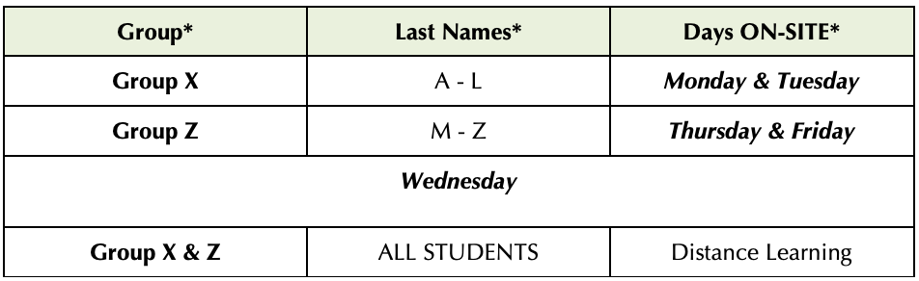
Hawking STEAM Charter School will administer a systemic cycle of assessments that include diagnostic, formative, summative and internal/local assessments.
- NWEA MAP ELA & Math Assessments: 3 times/year – Gr K-8
- Achieve 3000 Level Sets: 3 times/year – Gr K-8
- ESGI TK/K focused on grade level standards
- Daily formative assessments
- Summative Assessments

To ensure student learning and competency developing while also addressing the social emotional needs of students currently, we are providing developmentally appropriate strategies for understanding and regulating emotions and practicing self-care. By guiding families on how to create supportive home environments, and fostering an overarching commitment to creating connectedness across physical distance.
Teachers have embedded our school’s 3 C’s – Connections, Celebrations, and Challenges, into daily morning meetings and with monthly character trait lessons from our SEL Cloud 9 curriculum. The SEL lessons are aligned with grade groupings and different monthly themes which can be applied as check-in prompts or mindful breathing techniques.
Virtual professional learning for school staff on how to promote SEL and community building during distance learning has been provided for all teachers. Teachers have been instructed to contact the school counselor and/or Principal, including parents, when a student is not engaged. The school counselor and/or Principal is also assigned to contact families of students who need additional social emotional support, particularly those who may be most vulnerable to trauma or disengagement, each day to ensure ongoing touchpoints from the school and conduct “office hours” daily to keep up connections with students.
PPE & SAFETY
Options for Higher Risk Individuals
- Consideration of options for staff at higher risk for severe illness (including older adults and people of all ages with certain underlying medical conditions) that limit their exposure risk (e.g., telework, modified job responsibilities that limit exposure risk) when possible.
- Consideration of options for students at higher risk of severe illness that limit their exposure risk (e.g., virtual learning opportunities) when possible.
- Considerations will be consistent with applicable law, policies to protect the privacy of people at higher risk for severe illness regarding underlying medical conditions.
Social Distancing
Social distancing is an effective way to prevent potential infection. Hawking employees, students, parents, and visitors should practice staying approximately 6 feet away from others and eliminating contact with others as feasible. However, in the school setting, proper social distancing is not feasible in all areas of operation. Barriers and PPE will be used in these areas to minimize exposure risks on site.
Procedures will be in place to help eliminate direct exposure:
- Limiting student movement during the day where feasible
- Traffic Flow – Monitoring walking direction throughout the common areas of the in order to maintain the social distancing guidelines to the extent possible.
- Signage visible in hallways and public entrances about social distancing guidelines.

Arrival/Drop-off: Teachers will open classrooms by 8am and students will report directly to class.
In order to ensure the continued well-being of our students and our employees, the following guiding principles have been put in place:
- Staff and students’ health and safety come first
- Provide quality instruction to our students no matter the instructional setting
- Continued responsiveness to, and engagement with, our students, staff, and families
- Ensure equitable services for all students especially unduplicated pupils
The safety of our employees and students is our first priority. Upon reopening, our schools have been completely cleaned and disinfected and we will continue to adhere to all necessary safety precautions. In addition to the deep clean of the office and school before employees and students return, the cleaning steps outlined below are to be taken to disinfect workplace surfaces, chairs, tables, etc. to protect employees and reduce the risk of spread of infection. We will require employees to maintain this safety standard by continuously cleaning and disinfecting.
The goal is to establish a sanitary baseline before the site opens. The site should be 100% disinfected prior to anyone returning to work.
- All HVAC filters have been upgraded to a MERV 13 filtration system and service and maintenance will be increased from 4 times per year to 6 times per year.
- Any windows and doors that are available will remain open where possible.
- We will suspend or modify use of site resources that necessitate sharing or touching items.

The safety of our staff and students remains the school’s primary concern. As a result, Hawking will not allow normal visitation to our campuses. Instead, all visitations will be done by appointment or as allowed by school site administrators. To help prevent the spread of COVID-19 and reduce the risk of exposure to our staff and students, we are conducting a simple screening questionnaire.

To ensure the safety of students, staff, consistent with public health guidance we will teach and reinforce washing hands, avoiding contact with one's eyes, nose, and mouth, and covering coughs and sneezes among students and staff by delivery of lessons related to hygiene during the first two weeks of school.
- Teach students and remind staff to use tissue to wipe their nose and to cough/sneeze inside a tissue or their elbow.
- Students and staff should wash their hands before and after eating; after coughing or sneezing; after being outside; and before and after using the restroom.
- Students and staff should wash their hands for 20 seconds with soap, rubbing thoroughly after application, and use paper towels (or single use cloth towels) to dry hands thoroughly.
- Staff should model and practice handwashing. For example, for lower grade levels, use bathroom time as an opportunity to reinforce healthy habits and monitor proper handwashing.
- Students and staff should use fragrance-free hand sanitizer when handwashing is not practicable. Sanitizer must be rubbed into hands until completely dry. Note: frequent handwashing is more effective than the use of hand sanitizers.
- Ethyl alcohol-based hand sanitizers are preferred and should be used when there is the potential of unsupervised use by children. Isopropyl hand sanitizers are more toxic and can be absorbed through the skin.
- Children under age 9 should use hand sanitizer under adult supervision. Call Poison Control if consumed: 1-800-222-1222
- Teach and reinforce use of cloth face coverings, masks, or face shields. Face coverings are most essential when physical distancing is not practical.
- All staff will use cloth face coverings unless Cal/OSHA standards require respiratory protection. Teachers can use face shields, which enable younger students to see their teachers’ faces and to avoid potential barriers to phonological instruction.
- Food service workers and staff in routine contact with the public will use gloves and facial coverings.
- Students will be required to use cloth face coverings with few exceptions. Cloth face coverings are most essential in settings where physical distancing cannot easily be maintained, such as school buses or other settings where space may be insufficient.
- Students and staff should be frequently reminded not to touch the face covering and to wash their hands frequently.
- Information will be provided to all staff and families in the school community on proper use, removal and washing of cloth face coverings.
In order to minimize exposure to COVID-19, PPE will be provided to prevent certain exposures. PPE will include:

Face Shields: Face shields will be provided and available for use and as an added measure of protection for self and others.

Masks: Face masks are an important part of employee protection, as well as personal hygiene, social distancing, and frequent cleaning efforts.

Gloves: Touching your face with contaminated hands, whether gloved or not, poses a significant risk of infection. Wearing gloves does not diminish the need to wash your hands. Please remember to wash your hands properly as it is the number-one defense against any virus. (See Handwashing Routines) Additionally, the proper removal of gloves reduces the risk of being exposed to contamination.

Disposable Hazmat Suit: Available for Health Technicians and Custodians.

We will ensure adequate supplies to support healthy hygiene behaviors, including soap, tissues, no-touch trash cans, face coverings, and hand sanitizers with at least 60% ethyl alcohol for staff and children who can safely use hand sanitizer are available.

Handwashing Routines: We will add portable handwashing stations throughout the site and near classrooms to minimize movement and congregations in bathrooms to the extent possible. Students will be reminded to wash their hands often with soap and water for at least 20 seconds. Mandatory handwashing will take place for all upon arrival to the school, after recess, nutrition break, before/after lunch, and after coughing and sneezing.

Actions Related to In-Person Instructional Offerings
Description | Total Funds | Contributing
Principals (2) and classroom teachers for both sites to provide instruction for all students: in-person/distance learning platform. Our school’s daily instructional minutes far exceed the state’s SB98 requirements of 180 minutes for TK/K; 230 minutes for Gr. 1-3; and 240 minutes for Gr. 4-8.  All teachers participated in 8 days of intensive summer professional development (prior to the start of the 2020-21 school year); weekly professional development during the academic year; and 3 non-instructional full days have been added to the 2020-21 school year for additional professional development for all teachers focused on data analysis of student work and assessment; and developing plans to improve student achievement across all student groups, and accelerate student learning, during the academic year.  * 10% of teacher salaries will be funded with LCFF Supplemental & Concentration funds (contributing column) and the remaining 90% with LCFF Base Funds. Total amount funded with LCFF S&C: $509,409 | $5,094,099 | *Y
Procurement of PPE equipment, additional supplies, materials, partitions, janitorial services for personal protection, hygiene, health & safety and disinfecting classrooms, school equipment, etc. | $431,467 | N

Distance Learning Program

Continuity of Instruction
[A description of how the LEA will provide continuity of instruction during the school year to ensure pupils have access to a full curriculum of substantially similar quality regardless of the method of delivery, including the LEA’s plan for curriculum and instructional resources that will ensure instructional continuity for pupils if a transition between in-person instruction and distance learning is necessary.]
Hawking STEAM Charter School will begin the school year in a distance learning model with 100% of students off-campus.
High impact distance learning requires that our school and staff engage in distance learning best practices with an emphasis on work that promotes student ownership. Each teacher will work to establish conditions where students have a clear sense of purpose, opportunities to express themselves, and experiences that allow them to work toward grade level mastery. These practices will promote student engagement and motivation to learn in a distance learning platform. Students will receive instruction in all core subjects and electives that include but are not limited to: Robotics, Visual Arts, Coding, Music, Spanish, Orchestra, Band and Art.
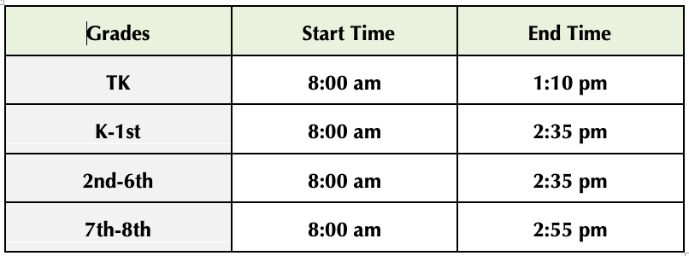
In distance learning, staff will be designing and delivering synchronous (face to face) instruction and asynchronous work (student-driven, independent, self-paced). These two components will be planned and delivered in coordination, rather than viewed as class time and homework. Students can and will learn content in asynchronous activities. Our school will utilize Google Classroom as the Learning Platform and Zoom meetings for synchronous instruction.
Synchronous Instruction: Synchronous, or face-to-face, teaching and learning requires students to be simultaneously logged into the virtual classroom at the same time as their teacher and classmates. Synchronous sessions are also referred to as live meetings. During these meetings, students will need to have internet access and an internet-enabled device with a camera and microphone. Earbuds or headsets are recommended. The live meeting app for remote learning will be a combination of Google Meets and Zoom depending on the teacher and/or grade level. When students log in to a live class, they are expected to be on camera and able to participate through audio for the duration of the class meeting. Students can unmute and mute themselves throughout class to make contributions according to the teacher’s expectations. If students are unable to participate in a live meeting, the teacher will post the recording for future viewing.
Asynchronous Instruction: Asynchronous (independent work/student led work) is the term used for course materials that teachers have prepared for students ahead of time. An example would be recorded lessons. Students engage with class materials and complete work at their own pace, typically within a given timeframe, often using discussion boards to drive peer-to-peer engagement.
When students are not in live sessions they will spend the remainder of their time in Asynchronous learning to prepare for and supplement their time in live sessions. Since students have access to this content 24/7, they can view and complete the material when it fits their schedule. Students will need internet access and should use their school computer. Course material will be designed to be flexible and can be accessed through mobile devices when appropriate.

English Learners: English Learners will receive both designated English Language Development (ELD) and Academic Language Development (ALD) 4 days per week utilizing Wit & Wisdom ELD curriculum for grades TK-6; and English 3D Curriculum for grades 7-8, and integrated ELD. To continue to develop English learner language skills, teachers will provide daily comprehensive English Language Development. Designated English Language Development “first teaching” will be provided through synchronous instruction via small groups differentiated by proficiency level. Asynchronous instruction will also be included to support of such instruction.

SPED & 504: To the extent that it is feasible, services and supports, as outlined in Individualized Education Programs (IEP) or Section 504 Plans (504 Plan) will continue as written. Education Specialists, Speech-Language Pathologists, Paraprofessionals, and therapists contracted through agencies will continue to work with students providing direct services, and with parents and caregivers providing indirect services. General and Special Education Teachers will continue to collaborate to provide applicable accommodations in accordance with IEPs or 504 Plans. Should distance learning pose new challenges for a student with an IEP or 504 Plan, a meeting will be convened to discuss student needs and revise the plan accordingly.
Our Students with Disabilities (SWD) require accommodations (and sometimes modifications) to access their curriculum. It is the responsibility of the Special Education and General Education teachers to ensure that our students receive as many of their accommodations as possible during Distance Learning to ensure full participation and access.

This summer Hawking participated in the National Summer School Initiative. It was a national pilot program designed to enhance the distance learning experience for students and teachers through the implementation of proven instructional practices for distance learning. What we learned from our participation informed the following key components of this Distance Learning Plan.
- Scheduling: The daily schedule provides a balance between synchronous and asynchronous learning; builds in small group collaboration and instruction; and allows time for students and their teachers to engage deeply in core curriculum.
- Intellectual Professional Development: Teachers increased their capacity to effectively manage learning management systems and provide rigorous and meaningful online instruction.
- Feedback: Teachers developed skill in reviewing online student work and providing regular feedback to students on their progress toward mastery.
- Mentor videos-partner: Master teachers partner with local teachers to model best practices and support Intellectual Professional Development.
Our students will use the following core curriculum:
- ELA: Wit & Wisdom (Gr. TK-8)
- ELD: Wit & Wisdom (Gr. TK-6); English 3D (Gr 7-8)
- Math: Eureka Math (Gr TK-8)
- Science: TCI (Gr TK-5); Know Atom (Gr 6-8)
- Social Studies: TCI
- SEL: Cloud 9 World; and Second Step
Our students will also utilize the following supplemental web-based programs and tools:
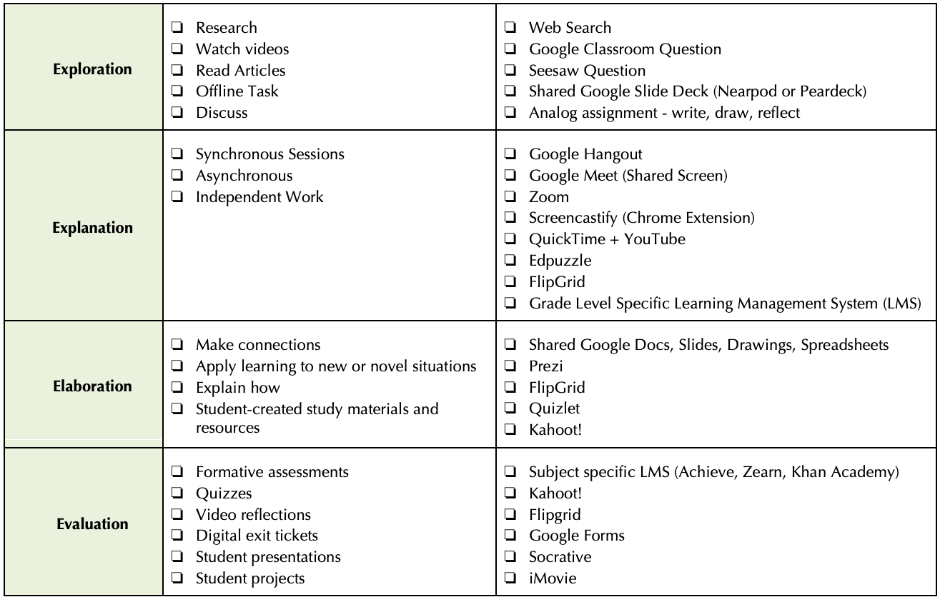
Distance Learning: Student & Parent Expectations
Hawking has developed student roles and responsibilities for distance learning, which include:
- Check appropriate online platforms for information on courses, assignments, resources daily
- Attend all scheduled live courses
- Participate and keep camera and microphone on
- Identify and use a comfortable and quiet space to study and learn
- Practice academic integrity as they engage in their learning-no cheating
- Submit all assignments in accordance with provided timelines and/or due dates
- Review assigned work and dedicate appropriate scheduled time to learning
- Maintain healthy habits recommended by teachers, counselors, and other Hawking staff
- Communicate with teacher(s) and seek assistance as needed
- Be a good digital citizen
- Show respect to yourself, teachers, and peers

Hawking has developed guidelines and expectations for parents/guardians that support their child with distance learning.
The transition to distance learning may be challenging for families. Parents and guardians will need to think differently about how to support their children; how to create structures and routines that allow their children to be successful; and how to monitor and support their children’s learning. The ten guidelines provided below are intended to help parents and guardians think about what they can do to help their children be productive and successful in a distance learning environment.

1) Establish routines and expectations: Hawking encourages parents/guardians to set consistent daily routines to ensure a successful school day. Students should plan to follow the schedule set for each grade level. We ask parents to set and monitor sleep times. Reinforce periodic breaks established in the teacher’s schedule. It is important that parents/guardians set these expectations for how their children will spend their days starting as soon as distance learning is implemented.
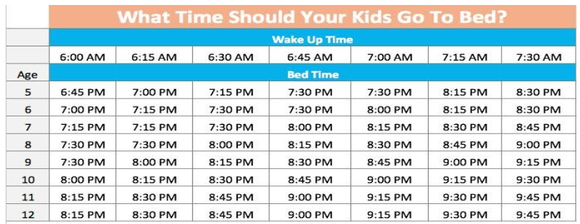

2) Define the physical space for your child’s study
Your child may have a regular place for doing homework under normal circumstances, but this space may not be suitable for an extended period of time, as will be the case with Distance Learning. We recommend that families establish a space or location where your student will learn most of the time. To ensure support and supervision, this should be a public or family space, not in a child’s bedroom. It should be a place that can be quiet and have a strong wireless internet signal, if possible. Below are the essential elements of creating an ideal Remote Learning Office that will be provided as a guidance for your child:
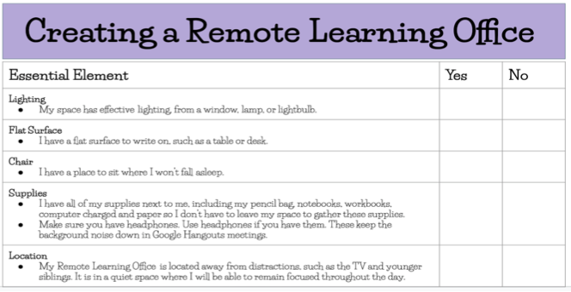
3) Monitor communications from your children’s teachers
Teachers will communicate with parents/guardians regularly via email, ClassDojo, chat, or telephone. If you need to talk with teachers they will be available during office hours.
4) Begin and end each day with a check-in
Establish morning routines that include normal hygiene practices and breakfast. Parents/Guardians are encouraged to start and finish each day with a simple check-in.
In the morning, ask your child the following: What, if anything, do you need to have a successful day? What support do you need? How can I help you?
At the end of the day, ask: What did you learn today? Is there anything you need extra help with?
You can also encourage your child to email the teacher in regards to any need. This is especially true for older students but this may become the parents’ responsibility for our younger students. These brief grounding conversations matter. They allow children to process the instructions they have received from their teachers. It helps them organize themselves and set priorities. Older students may not want to have these check-ins with parents/guardians (that is normal!), but parents should do so nevertheless.
Parents/Guardians should establish these check-ins as regular parts of each day. Not all students thrive in a distance learning environment; some struggle with too much independence or lack of structure. These check-in routines need to be established early, before students fall behind or begin to struggle.
5) Take an active role in helping your child process and own their learning
In the course of a regular school day at Hawking, your child engages with other students or adults dozens if not hundreds of times. These social interactions and opportunities for mediation include turning to a peer to exchange a thought or idea, participating in small or large group discussions, asking questions for clarification, collaborating on group projects, and countless other moments. While some of these social interactions will be re-created on Distance platforms, others will not. Human beings learn best when they have opportunities to process their learning with others. Beyond the check-ins recommended at the start and end of each day, parents/guardians should regularly circle back and engage with their student(s) about what they’re learning. However, it’s important that your child owns their work; don’t complete assignments for them, even when they are struggling.
6) Establish times for quiet thought and reflection
A huge challenge for families with multiple children will be how to manage all of their needs, especially when those children are different ages and have different needs. There may be times when siblings need to work in different rooms to avoid distraction. Parents/Guardians may even experiment with noise-cancelling headphones (no music necessary) to block out distractions.
7) Encourage physical activity and/or exercise
Make sure your child remembers to move and exercise. Physical Activities and brain breaks will be incorporated within your child’s daily schedule given by their classroom teacher. This is vitally important to their health, wellbeing, and to their learning. Hawking’s physical education teacher will recommend activities or exercises, but it is important for parents/guardians to model and encourage exercise.
8) Remain mindful of your child’s stress or worry
During the implementation of the Distance Learning Plan, it is imperative for parents/guardians to help their child manage the worry, anxiety, and range of emotions they may experience. Difficult as it may be, do your best not to transfer your stress or worry to your children. They will be out of sorts, whether they admit it or not, and need as much normal routine as parents/guardians can provide. Please reach out to your school’s counselor (H1 counselor and H2 counselor) should he/she experience high levels of stress or worry.
9) Monitor how much time your child is spending online
Hawking does not intend for our students to stare at computer screens for 7–8 hours a day. Hawking principals, counselors or teachers will periodically check in with you to assess what you’re seeing at home and what we need to adjust. We thank you in advance for your patience and partnership!
10) Keep your child social, but set rules around their social media interactions
Please monitor your child’s social media use. Older children will rely more on social media to communicate with friends. Social media apps such as SnapChat, Instagram, WhatsApp, or Facebook are not official, school-sanctioned channels of communication and are not age appropriate platforms. Hawking asks that parents/guardians to monitor their child’s use of online communication platforms. Remind your child to be polite, respectful, and appropriate in their communications and to represent your family’s values in their interactions with others. A child’s written words and tone can sometimes offend or cause harm to others.

Access to Devices and Connectivity
[A description of how the LEA will ensure access to devices and connectivity for all pupils to support distance learning.]
For the distance learning program, Hawking will provide devices and software to communicate assignments, to deliver live lessons, and to execute some assignments. All students and teachers will have access either to a MacBook, Chromebook, or iPad to participate in the educational program through distance learning. Based on our school’s technology needs assessment, 90% of our families identified the need for a device for their child to access the distance learning program; and approximately 6% lack connectivity at home. All students/families that requested a device were issued one; and Wi-Fi hotspots were also issued. In addition, we have informed families of resources available to low-income households from local internet service providers to ensure all families are equipped with the internet services needed for distance learning. Internet Essentials from Comcast brings families affordable, high-speed Internet that makes it easier for low-income households to get connected so they can more easily work from home, access educational resources and stay in contact with friends and family.
Our school sites provide daily tech-support virtually, via phone call and by appointment onsite at our school.

Pupil Participation and Progress
[A description of how the LEA will assess pupil progress through live contacts and synchronous instructional minutes, and a description of how the LEA will measure participation and time value of pupil work.]
For Hawking STEAM Charter School students to succeed in accomplishing the mission of our school, it is imperative to maintain regular and punctual school attendance. All students are expected to be on time to their Zoom classes every day and to complete their independent learning assignments. Teachers have a designated time, each week, to conduct small group and 1:1 formative assessment on student language development progress since all students have access to technology.
California requires that students have “daily live interaction” with a “certificated employee and their peers for purposes of instruction, progress monitoring, and maintaining school connectedness.” (Ed Code 43503(b). Also, each LEA must “document daily participation for each pupil on each school day, in whole or in part, for which distance learning is provided.”
Teachers must document daily engagement for each student. A student who participates in online/in-person learning on a given day will be marked Present for the day. If a student does not participate in online/in-person learning will be marked Absent for the day. Participation includes:
- Attendance to live class sessions (online or in-person)
- Attendance to live intervention groups (online or in-person)
- Attendance to teacher office hours
AND
- Completion of Asynchronous Learning - Students are expected to complete all work assigned to them in their Google Classroom each day in order to be marked as present/fully-engaged.

A student will be marked Absent if he/she does not engage in either of the above ways. The credentialed teacher will determine whether the extent to which a student engages each day is sufficient to be marked present for the day.

Each teacher will take attendance daily in PowerSchool. Additionally, teachers will complete a Weekly Student Engagement Record documenting synchronous and asynchronous instruction each day of distance learning within a given week. The purpose of this document is to measure the extent to which a student is engaged each week. The goal is to have 100% engagement from each student. This engagement includes not only attending class sessions, but also completing assignments with optimal effort. Teachers will indicate whether students attend class sessions and complete assigned asynchronous learning activities each day. Teachers will sign and certify the accuracy of their Weekly Student Engagement Record at the end of each week, for every student.
Education Code Section 43502(e)(1). Services delivered via distance learning will count toward the minimum number of instructional minutes based on the time value of assignments as determined, and certified to, by a Hawking Charter School credentialed teacher. Services delivered via distance learning must be evaluated and certified by a properly credentialed staff member, and the time value of those services, as determined by the credentialed employee, will count toward minimum instructional minutes. These assignments can be both synchronous and/or asynchronous. Time Value is defined as the Instructional time for distance learning is calculated based on the time value of synchronous and/or asynchronous assignments made by and certified by a certificated employee of the LEA. Time value for distance learning is different than time value used previously in independent study programs which include an evaluation of the time value of work product.

Distance Learning Professional Development
[A description of the professional development and resources that will be provided to staff to support the distance learning program, including technological support.]
Hawking STEAM Charter school has designed the following professional development for teachers and staff to ensure the delivery of high quality instruction via distance learning.
- 1 week of professional development June 2020 – Distance learning thinking – National Summer School Initiative training
- August 2020: Safety Protocols; Distance Learning Plan; Preparation, Guidelines for Home visits, setting up Google Learning Platform, and technology based applications for distance learning
- School culture and Character Building
- Professional Reading
- Understanding, assessing and certifying Time Value for assignments per SB98 (Credentialed teachers)
Additional professional learning will be added as necessary, in order to best meet the needs of teachers and students.
Workshop for teachers on meeting the needs of SWD: modifications and accommodations.

Teachers are participating in two 45 minute sessions weekly. This Intellectual Professional Development allows teachers to collaborate with a mentor teacher provided by Cadence Learning (formerly NSSI).

Staff Roles and Responsibilities
[A description of the new roles and responsibilities of affected staff as a result of COVID-19.]
The roles and responsibilities of our staff have been modified to align with distance learning needs; and additional requirements per SB98.

Supports for Pupils with Unique Needs
[A description of the additional supports the LEA will provide during distance learning to assist pupils with unique needs, including English learners, pupils with exceptional needs served across the full continuum of placements, pupils in foster care, and pupils who are experiencing homelessness.]
Our entire teaching staff scheduled Virtual Home Visits the week before school started to engage with families and welcome them to the new school year. This was also an opportunity to determine the specific needs of families and provide individualized tutorials on topics such as virtual classroom access and navigation. Since then, students with unique needs have been provided support including remote visual schedules, step-by-step PowerPoint tutorials, and non-digital work, as needed.
The Teacher Support for Student Success (TS3) binder has been digitized and substantially revised to ensure that all staff have the resources available to provide equitable access and meaningful participation for our students. This tool provides descriptions, examples, and resources from the Collaborative for Academic, Social, and Emotional Learning (CASEL) and Universal Design for Learning (UDL). There is a section, Accommodations and Modifications During Distance Learning, that provides explicit examples of strategies for teachers and caregivers.

Special Education (Education Specialists) and General Ed teachers plan regular meetings to collaborate and adjust instructional schedules and lessons, analyze formative assessment of linguistic and academic data to meet the needs of dually identified students.
During designated times for small group instruction, the Education Specialist or paraprofessionals supports the General Education teacher to provide additional language and content support in a breakout room to support dually identified students.

Actions Related to the Distance Learning Program
Description | Total Funds | Contributing
Technology devices, wi-fi hotspots, internet, headsets, IT support | $121,800 | N
SPED Staff and Services for students | $1,101,366 | N
Professional Development Costs for Teachers & staff on topics addressed throughout this plan.  * Partial funding with Title II; and LCFF S&C Funds: | $70,330 | *Y
Online core curriculum (subscription): Eureka Math, TCI Science & Social Studies, Know Atom | $315,000 | N
Technology-based supplemental instructional materials including but not limited to: Google Classroom, Zoom, SeeSaw, NearPod, Peardeck, Screencastify, EdPuzzle, Flipgrid | $25,000 | Y
After School academic and social enrichment program | $133,170 | N
Enrichment & Electives Program: Art, Music, Robotics and Visual Art | $332,603 | Y

Pupil Learning Loss
[A description of how the LEA will address pupil learning loss that results from COVID-19 during the 2019–2020 and 2020–21 school years, including how the LEA will assess pupils to measure learning status, particularly in the areas of English language arts, English language development, and mathematics.]
As a result of school closure due to COVID-19 in mid-March, our entire staff shifted their instructional practice to Distance Learning. We implemented various strategies to engage students and consistently increase student participation. Our staff communicated with families on a regular basis which has continued throughout the summer and has led to the development of the Learning Continuity and Attendance Plan.
Throughout the transition to distance learning Hawking STEAM Charter School has been implementing actions to mitigate learning loss. For the 2020-21 school year, we have developed a cycle of assessment including diagnostic to determine present student academic levels which will serve as a baseline; and for identification for intervention, differentiation and additional support in order to accelerate student learning. The diagnostic assessments are focused on ELA, Math and ELD which will guide instructional and curricular planning.
Hawking STEAM Charter School will administer a systemic cycle of assessments that include diagnostic, formative, summative and internal/local assessments.
- NWEA MAP ELA & Math Assessments: 3 times/year – Gr K-8
- Achieve 3000 Level Sets: 3 times/year – Gr K-8
- ESGI TK/K focused on grade level standards
- Daily formative assessments
- Summative Assessments
Findings from initial diagnostic assessments in ELA, Math and ELD will be used to identify and provide additional academic supports, to mitigate learning loss and accelerate student learning. English learner research-based intervention, that incorporates innovation, ELD strategies and access to instructional technology, will be provided by teachers during the instructional day via small group ELA and Mathematics instruction with integrated English language development, for English learners in grades K-8.
For ELA – students will participate in the Achieve 3000 intervention block; and for math, students will receive small group instruction during the instructional day.
All students in grades 6-8 participate in daily AVID (30 minutes) during Advisory block. Students will learn research-based practices and strategies critical in order to be an effective learner. The strategies focus on: Writing, Inquiry, Collaboration, Organization, and Reading. Our teachers received extensive training on implementing these strategies through distance learning.
Students will participate in Student-Led Conferences (SLC) where they evaluate and monitor their own progress. The purpose of SLC is to allow students to reflect on their academic progress, set/develop goals, and celebrate accomplishments. SLCs will take place each semester (fall/spring). Students will also participate in STEAM Expos, an opportunity to display the culmination of their work, that will take place in the Winter and Spring.

Pupil Learning Loss Strategies
[A description of the actions and strategies the LEA will use to address learning loss and accelerate learning progress for pupils, as needed, including how these strategies differ for pupils who are English learners; low-income; foster youth; pupils with exceptional needs; and pupils experiencing homelessness.]
Approximately 75% of our students are Unduplicated Pupils (English Learner, Low-income, foster youth), and the strategies that have been discussed throughout this plan are based on evidence-based practices, that primarily support the needs of our Unduplicated Pupils and Students with Disabilities.
English learner research-based intervention, that incorporates innovation, ELD strategies and access to instructional technology, will be provided by teachers during the instructional day via small group ELA and Mathematics instruction with integrated English language development, for English learners in grades TK-8.
Our distance learning program incorporates academic supports and targeted intervention in ELA, Math and English Language Development, led by our teachers and in collaboration with our Instructional Assistants. Our plan includes an increase in daily synchronous instruction; and our daily instructional minutes exceed the CA requirement of:
- Grades TK/K: 180 minutes
- Grades 1-3: 230 minutes
- Grades 4-8: 240 minutes
Student Study Team (SST) protocols will be reviewed at the beginning of the year. Follow up meetings for students previously monitored will be scheduled and new teachers informed of student needs. PLC meetings will focus on current intervention and classroom supports in order to differentiate instruction as necessary. PLC teams will analyze data, and student products to determine student needs or next steps.

Our school has implemented a 1:1 student to device ratio. During distance learning technology devices and/or Wi-Fi hotspots have been provided to ensure students have full access to our instructional program and intervention supports. Our staff has designed tutorials for students/families, provided a technology support hotline, and onsite drop-in technology support.

Effectiveness of Implemented Pupil Learning Loss Strategies
[A description of how the effectiveness of the services or supports provided to address learning loss will be measured.]
The Leadership Team and teachers will use Improvement Science research through the Plan, Do, Study, Act (PDSA) model through its Multi-tiered System of Supports (MTSS). This model of continuous improvement is used to measure program effectiveness at Hawking. Our goal is to optimize program and strategies in place by analyzing and evaluating its effectiveness, planning change to optimize a program or strategy, implement the Action Plan and continue to study the results/findings. The PDSA cycle is a Continuous Improvement Cycle.

Data that will be collected includes diagnostic assessments, formative, trimester assessment that will be used for the PDSA process. These assessments outlined under “Pupil Learning Loss” will allow our educators to measure student performance over time for growth and progress; identify learning gaps, and include predictive growth, which is used to accelerate learning.

Actions to Address Pupil Learning Loss
Description | Total Funds | Contributing
Implementation of a Systemic Cycle of Assessments: NWEA, ESGI, & Achieve 3000, ongoing standards-aligned assessment to, identify learning loss and learning gaps, and monitor student academic progress by grade level and student group, and assess the effectiveness of our programs. | $50,000 | Y
ELPAC Testing Administrator & SST Coordinator; and ELPAC Testers | $114,323 | N

Mental Health and Social and Emotional Well-Being
[A description of how the LEA will monitor and support mental health and social and emotional well-being of pupils and staff during the school year, including the professional development and resources that will be provided to pupils and staff to address trauma and other impacts of COVID-19 on the school community.]
To address the mental health, social and emotional well being of students Hawking will implement the Search Institute’s Building Developmental Relationships During the COVID-19 Crisis, a school-based mental health initiative that is designed to build resilience and allow children to thrive. This tool will also support the development of a strong class culture. Teachers will be expected to observe the following guidelines:
- Practice greeting students when they enter a video Zoom meeting (Virtual)
- Consistently teach and reinforce Second Step and Cloud 9 world Concepts
- Plan for opportunities to build positive relationships with each student
- Plan for opportunities for students to build positive relationships with their peers
- Plan for opportunities for collaborative work and communication among peers throughout the school day.
School counselors are available to support students and their families. Our school has partnered with SouthBay Community Services and the Chula Vista Community Collaborative for referrals for our students/families to receive additional mental health services.

To address the mental health, social and emotional well-being of staff Hawking STEAM Charter School will implement the following strategies:
- Principals will encourage staff to incorporate basic self-care strategies into daily routines.
- Provide opportunities for teacher-to-teacher connections, and teacher mentor or partners.
- Encourage mindfulness, yoga, and/or meditation
- Regular reminders of our Employee Assistance Program (mental health services program)
Our staff will participate in professional development that addresses trauma and other impacts of COVID-19. The first module of our professional reading, The Distance Learning Playbook is “Take Care of Yourself” and it includes key ideas on how to persevere during challenging times. The learning intentions of the module are:
- I am learning to take care of myself as I engage with my students. I am learning about the impact of trauma on educators.
Our staff participated in “the Distance Learning Playbook” 1-day professional learning led by Corwin Publishers and Dr. Nancy Frey. All teachers have received a digital copy of the book and this will guide our professional development on trauma.

Hawking STEAM Charter School recognizes that students, their families, and staff may have a range of responses to the stress of the COVID-19 outbreak, isolation, loss, and the uncertainty of returning to school. All staff will carefully monitor students for signs of stress and take steps to help students cope.
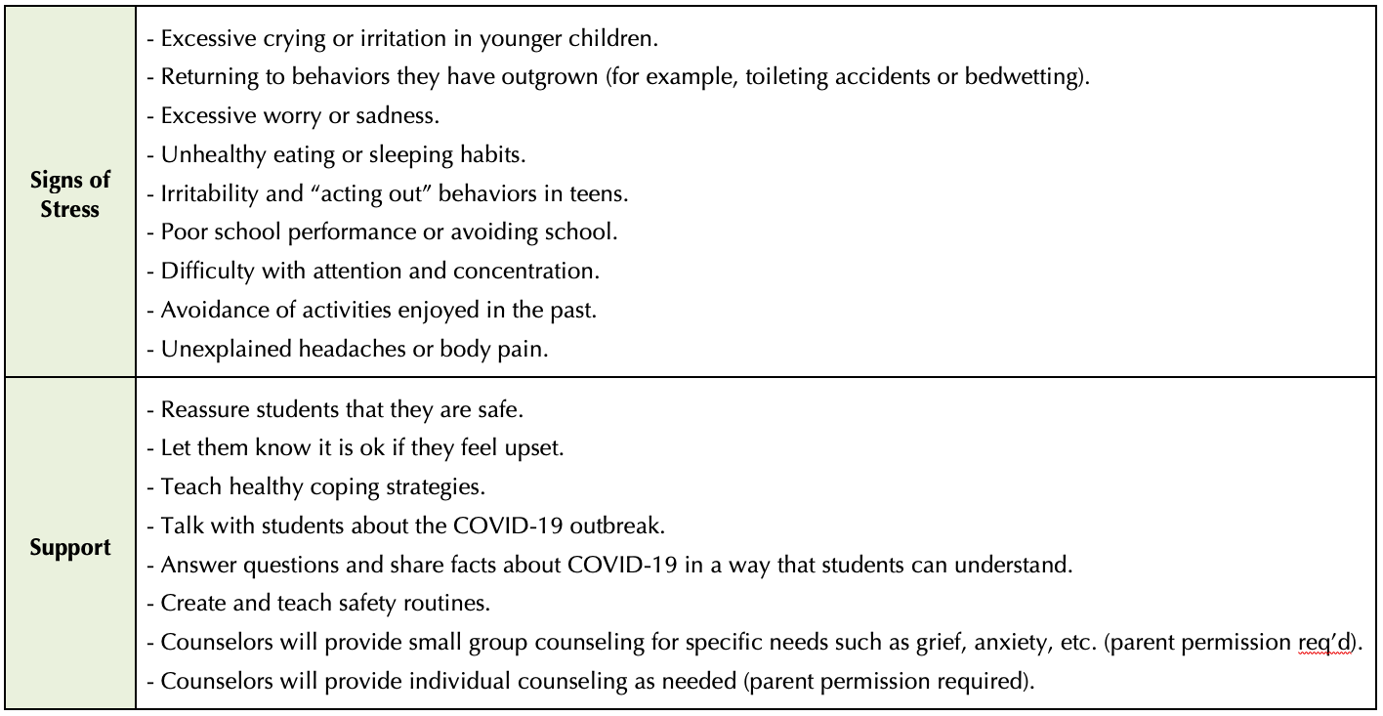

Pupil and Family Engagement and Outreach
[A description of pupil engagement and outreach, including the procedures for tiered reengagement strategies for pupils who are absent from distance learning and how the LEA will provide outreach to pupils and their parents or guardians, including in languages other than English, when pupils are not meeting compulsory education requirements, or if the LEA determines the pupil is not engaging in instruction and is at risk of learning loss.]
Our entire teaching staff scheduled Virtual Home Visits the week before school started to engage with families and welcome them to the new school year. This was also an opportunity to determine the specific needs of families and provide individualized tutorials on topics such as virtual classroom access and navigation. The purpose of this meeting was to ensure that all students and parents would know and fully understand the expectations with distance learning including the student’s daily instructional schedule and how to access the learning platforms and instructional applications. Translator services were provided for families whose primary language was not English.
Hawking teachers and staff communicate with families on a regular basis using multiple methods including email, ClassDojo, Zoom, telephone, PowerSchool Parent Portal, Coffee with the Principal, to name a few. All teachers will offer daily office hours virtually for students and parents.
Our school will implement the following additional venues to communicate school updates with families:
- July 29th – Parent Forum
- Coffee with the Principal: Monthly/bi-monthly
- Back-to-School Nights: During the month of September
Student participation in distance learning will be tracked daily on the distance learning tracker. When students do not attend instructional blocks during the day, it will be documented in the distance learning tracker. Our school has designed a distance learning tracker that includes all of the components in the CDE’s Combined Daily Participation and Weekly Engagement Template (Education Code (EC) Section 43504)
Hawking STEAM Charter School has developed a tiered reengagement strategy for all students who are absent from distance learning for more than 3 school days or 60% of the instructional days in a school week per Senate Bill 98.
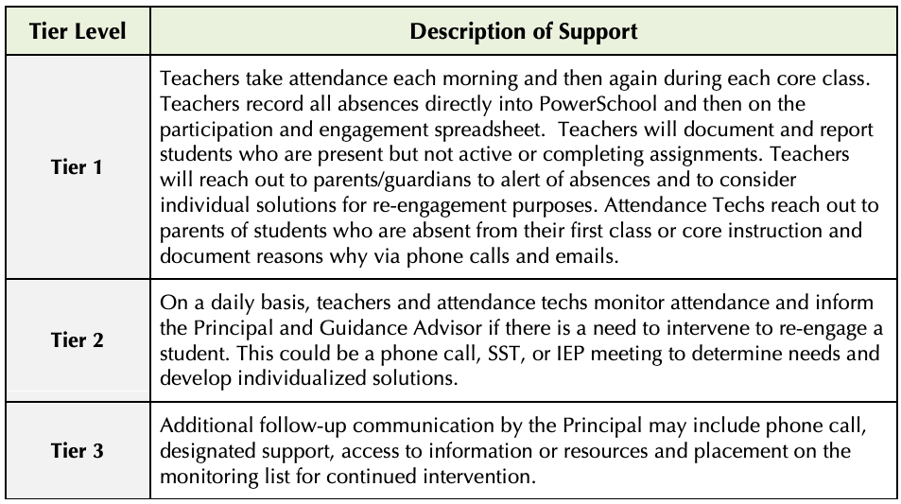

School Nutrition
[A description of how the LEA will provide nutritionally adequate meals for all pupils, including those students who are eligible for free or reduced-price meals, when pupils are participating in both in-person instruction and distance learning, as applicable.]
Hawking STEAM Charter School has disseminated school lunch applications to all families to evaluate students’ eligibility for free or reduced-priced meals to ensure all qualifying students are served.
Hawking STEAM Charter School will provide nutritionally adequate meals for all pupils, including those students who are eligible for free or reduced-price meals. For students attending in-person instruction, meals will be delivered to each classroom for both breakfast and lunch. The meals that are provided by our food service provider will be individually packaged for health safety and ease of distribution. Students will eat in their classrooms and practice all safety guidelines practicable.
During Distance Learning: Grab & Go meals will be made available weekly on Mondays at each school site that will include a total of 5 breakfasts and 5 lunches, for families to pick up, via curbside in a non-congregate setting. To ensure social distancing and “no-touch” pick-up, families will line up alongside the school building maintaining six-feet apart daily meals; or via curbside pick-up.
Hawking STEAM Charter School will also partner with community-based agencies, nonprofit organizations, and faith-based groups to provide direct food assistance to families including but not limited to information about food pantries/banks, and community events providing food disbursement.

Additional Actions to Implement the Learning Continuity Plan
Section | Description | Total Funds | Contributing
Mental Health and Social and Emotional Well-Being | Counselors – provide social-emotional counseling (2) | $228,225 | Y
Pupil & Family Engagement & Outreach | Support Staff, translators to contact families daily, provide tech-support, troubleshoot issues that students and families are having to maximize student daily attendance and participation in distance learning. | $250,000 | Y
School Nutrition | Nutrition services (Breakfast/lunch) | $220,000 | N

Increased or Improved Services for

Foster Youth, English Learners, and Low-Income Students
Percentage to Increase or Improve Services | Increased Apportionment Based on the Enrollment of Foster Youth, English Learners, and Low-Income students
18.6% | $1,699,367

Required Descriptions
[For the actions being provided to an entire school, or across the entire school district or county office of education (COE), an explanation of (1) how the needs of foster youth, English learners, and low-income students were considered first, and (2) how these actions are effective in meeting the needs of these students.]
Hawking STEAM Charter School is a public charter school that serves a highly vulnerable community. Hawking has a student enrollment of unduplicated pupils in excess of 75% of the total enrollment. Unduplicated pupils are defined as a student in one of the following groups: eligible for free/reduced price meals, foster youth, and English Learner.
Our distance learning program (in-person/distance learning) for the 2020-21 school year was designed based on feedback from our stakeholders (parents, students, staff, teachers) and an analysis of multiple types of data including coursework, student participation rates, academic grades, analysis of student work, survey results, CA Dashboard, assessment results including NWEA (reading/math) and Achieve 3000 that was administered remotely in June 2020. We are now updating and revamping our hybrid-learning program.
We identified the need for significant academic support for all students; and additional targeted support for Unduplicated Pupils; and the need strengthen the method and modality of the delivery of those supports and daily instruction. The addition of coaching and support for our teachers to be effective facilitators of knowledge in a virtual learning environment was critical, including designing and delivering daily synchronous engaging lessons for all students that includes scaffolds and the use of daily exit tickets (formative assessments) across all disciplines to check for student understanding.
In order to mitigate further learning loss and accelerate student learning, our daily instructional day in distance learning provides every student with synchronous and asynchronous instruction; small group instruction/intervention; and electives/enrichment. In order to narrow and close the achievement gap among Unduplicated Pupils, it was critical for our school to provide additional instructional minutes, not less as outlined in SB98.
As discussed in this plan, within the instructional day, an intervention block was added, to provide small group targeted instruction, including the use of evidence-based tools such as Achieve 3000.
Teachers also provide daily office hours (after-school) for one-on-one support and this is also an opportunity for parents to meet with teachers.
English Learners: English Learners will receive both designated English Language Development (ELD) and Academic Language Development (ALD) 4 days per week utilizing Wit & Wisdom ELD curriculum for grades TK-6; and English 3D Curriculum for grades 7-8, and integrated ELD that takes place across all disciplines. To continue to develop English learner language skills, teachers will provide daily comprehensive English Language Development. Designated English Language Development “first teaching” will be provided through synchronous instruction via small groups differentiated by proficiency level. Asynchronous instruction will also be included to support of such instruction.
SPED & 504: To the extent that it is feasible, services and supports, as outlined in Individualized Education Programs (IEP) or Section 504 Plans (504 Plan) will continue as written. Education Specialists, Speech-Language Pathologists, Paraprofessionals, and therapists contracted through agencies will continue to work with students providing direct services, and with parents and caregivers providing indirect services. General and Special Education Teachers will continue to collaborate to provide applicable accommodations in accordance with IEPs or 504 Plans. Should distance learning pose new challenges for a student with an IEP or 504 Plan, a meeting will be convened to discuss student needs and revise the plan accordingly.
Our Students with Disabilities (SWD) require accommodations (and sometimes modifications) to access their curriculum. It is the responsibility of the Special Education and General Education teachers to ensure that our students receive as many of their accommodations as possible during Distance Learning to ensure full participation and access.
Throughout the transition to distance learning Hawking STEAM Charter School has been implementing actions to mitigate learning loss. For the 2020-21 school year, we have developed a cycle of assessment including diagnostic to determine present student academic levels which will serve as a baseline; and for identification for intervention, differentiation and additional support in order to accelerate student learning. The diagnostic assessments are focused on ELA, Math and ELD which will guide instructional and curricular planning.
Hawking STEAM Charter School will administer a systemic cycle of assessments that include diagnostic, formative, summative and internal/local assessments.
- NWEA MAP ELA & Math Assessments: 3 times/year – Gr K-8
- Achieve 3000 Level Sets: 3 times/year – Gr K-8
- ESGI TK/K focused on grade level standards
- Daily formative assessments
- Summative Assessments
Findings from initial diagnostic assessments in ELA, Math and ELD will be used to identify and provide additional academic supports, to mitigate learning loss and accelerate student learning. English learner research-based intervention, that incorporates innovation, ELD strategies and access to instructional technology, will be provided by teachers during the instructional day via small group ELA and Mathematics instruction with integrated English language development, for English learners in grades TK-8.
For ELA – students will participate in the Achieve 3000 intervention block; and for Math, students will receive small group instruction during the instructional day.
All students in grades 6-8 participate in daily AVID (30 minutes) during Advisory block. Students will learn research-based practices and strategies critical in order to be an effective learner. The strategies focus on: Writing, Inquiry, Collaboration, Organization, and Reading. Our teachers received extensive training on implementing these strategies through distance learning.
In order to increase student engagement and motivation; especially with distance learning, our school hired single-subject credentialed Art, Music and Visual Art teachers to teach these electives that previously taught by the classroom teacher who also teaches all core subjects. According to extensive research, teaching through the arts can present difficult concepts visually, and therefore easier to understand. Art instruction helps children with the development of motor skills, language skills social skills, decision-making, risk-taking and inventiveness. According to a report by the Rand Corporation, involvement in the arts is associated with gains in math, reading, cognitive ability, critical thinking and verbal skills. Arts learning can also improve motivation, concentration, confidence and teamwork.
The shift from in-person instruction to distance learning as a result of COVID-19 has further exacerbated and created more trauma for students especially for low-income, foster youth, and those with extended families living in the same household. Our students have been faced with social isolation, food scarcity, parental unemployment, and the pandemic has destabilized support system, resulting in further trauma to students. Our school Counselor’s role is to provide the social-emotional support and counseling services virtually and in-person once site-based instruction resumes.
A tiered reengagement plan led by the Principal in collaboration with the work that our bilingual support staff are accomplishing on a daily basis which includes contacting families/students in the morning when students are absent; or for non-participation, and/or when coursework/assignments are not completed. Our daily tracker that teachers use to document attendance is reviewed and monitored by the Principal and support staff so we can identify absences in “real-time.” Our support staff also provides tech-support (virtually and over the phone); in addition to trouble-shooting any issues identified by families/students; translating documents, providing translation services, and addressing any and all issues. The Principal will facilitate parent meetings, parent workshops, communicate with families on policies (revised), discuss student and parent expectations in the distance learning model, and implement the tiered reengagement strategies.

[A description of how services for foster youth, English learners, and low-income students are being increased or improved by the percentage required.]
Our student population are more likely to have interruptions in their education, impacted by trauma, face food insecurity, struggle academically and require additional academic support to access grade level instruction, and mental health and social-emotional support to address their SEL needs from traumatic experiences. The actions and services provided for our Unduplicated Pupils have been strategically designed and targeted to meet the student’s unique needs through our school’s Multi-tiered System of Supports (MTSS).
All services provided are principally directed toward and effective in meeting our school’s goals for unduplicated pupils especially with the state priorities. Our educational program and services are research and evidence-based to support and accelerate student learning for all of our students and targeted to meet the needs of our Unduplicated Pupils through our Multi-tiered System of Supports (MTSS) structure.
Based on our needs assessment and CA dashboard results, there is a need to strengthen, improve and address student performance in ELA and Math; including additional support for English Learners. The actions in our Learning Continuity and Attendance Plan are being provided on an LEA-wide basis in order to improve the academic achievement of all students. Targeted academic and social-emotional support services focus on strategies to meet the needs of our Unduplicated Pupils, to accelerate learning. In addition, our staff will collaborate with families as partners in their child’s education and will continue to provide training and support on our distance learning platforms.

